Assessment of the Variation of the Physicochemical Quality of Groundwater in Dasmariñas, Cavite and its Suitability for Drinking Purpose

R.Q. Macasieb*¹⁾, A.C. Resurreccion²⁾, R.G.R. Rubio³⁾
¹⁾Institute of Civil Engineering, University of the Philippines Diliman
²⁾ Institute of Civil Engineering, University of the Philippines Diliman
³⁾ Institute of Civil Engineering, University of the Philippines Diliman
* rqmacasieb@up.edu.ph
Keywords: Groundwater Quality; Water Quality Index, WQI, GIS
Introduction
The City of Dasmariñas is one of the most urbanized cities in the Philippines. It is the most populated city in the province of Cavite, which is at the same time the most populated province in the country (PSA, 2015). It houses many educational and health institutions, on top of its numerous commercial and industrial establishments. With rapid urbanization comes the tremendous demand for resources, particularly water resources. Currently, the primary source of water supply in the city is groundwater.
Urbanization brings about many pollution sources that may be contributing to the degradation of the quality of groundwater and may cause a significant impact in the community like major health problems. These unprecedented challenges and risks can be prevented by regular quality monitoring of groundwater.
This study aims to investigate the variation in the physicochemical quality of groundwater in Dasmarinas over the past years and evaluate its suitability as a source of water supply especially for drinking purpose.

Material and Methods
Semi-annual groundwater quality monitoring reports were collected from the Dasmariñas Water District (DWD). Data on turbidity, color, odor, bicarbonate (HCO₃⁻), carbonate (CO₃²⁻), pH, calcium (Ca2+), magnesium (Mg2+), total hardness, chloride (Cl⁻), fluoride (F⁻), iron (Fe), manganese (Mn), lead (Pb), specific conductance (SpC), and total dissolved solids (TDS) were gathered from 99 wells. GIS was used to visualize how the parameters vary spatially and temporally. Ordinary Kriging (OK) was used to estimate concentrations of measured water quality parameters for the unknown values throughout the study area. (OK) is one of the the most commonly adapted methods of interpolation that has been used by many research including Al-Adamat, Al-Mashagbah, and Salameh (2011) and Hassan (2014).
One-Sample t-Test with 99% confidence level of all the annual measurements was used to determine whether the measured water quality parameters meet the specified local and international standards including the Philippine National Standards for Drinking Water (PNSDW) 2007, DENR Administrative Order (DAO) No. 2016-08, World Health Organization (WHO) Guidelines for Drinking Water Quality, Guidelines for Canadian Drinking Water Quality (GCDWQ), and U.S. National Primary and Secondary Drinking Water Regulations (NPDWRs and NSDWRs).
Scores for the groundwater quality in Dasmariñas were computed for each year using the CCME WQI. The CCME WQI scores the water quality from 0 to 100, with 100 being the highest and corresponding to the optimum water quality. This method has been widely used because of its many advantages, some of which are simple process of calculation, flexibility in the selection of parameters to be considered and the water quality standards to be used, tolerance to missing data, and adaptability to specific conditions (Barcelo, Borrell, Campos, Tauler. & Terrado, 2010).

Results and Conclusions
The quality of the groundwater in Dasmariñas change spatially and temporally with regards to the parameters analyzed. CO₃²⁻, Ca²⁺, total hardness, Cl⁻, SpC. and TDS concentrations were found to be generally increasing from the south to north part of the city, while Color and Pb were detected only during certain instances as shown in Figures 2 and 3.
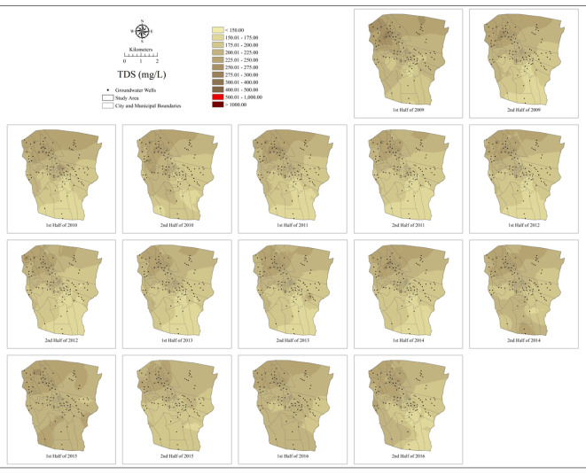
Figure 1. TDS concentration maps from 2009 to 2016
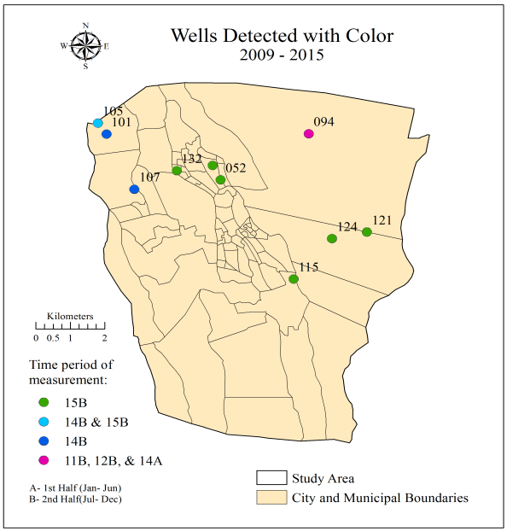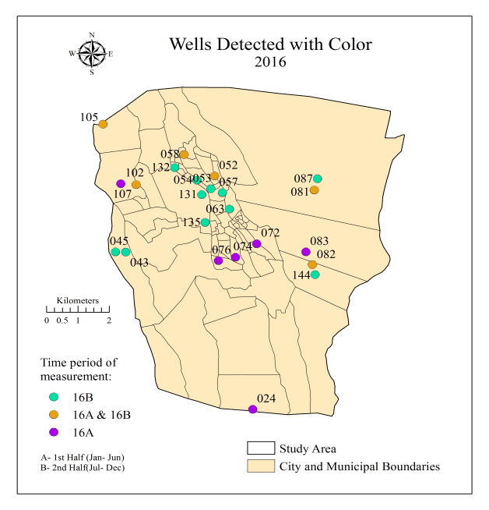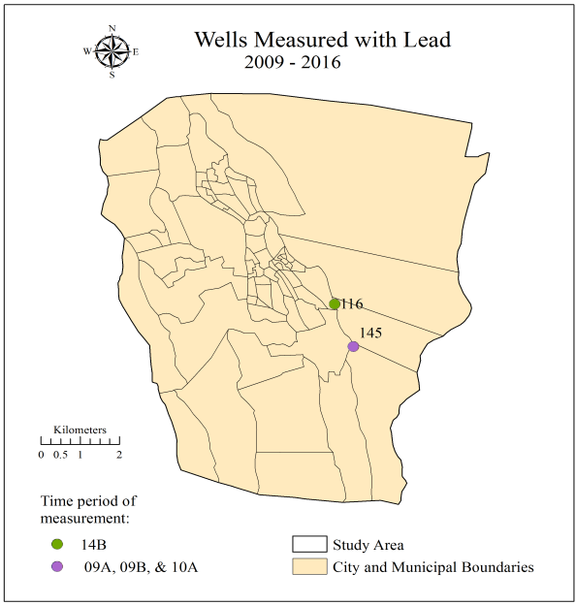
Figure 2. Wells detected with color or with Pb
Through One-Sample t-Test, the groundwater in Dasmariñas was found to be compliant with the regulations of the PNSDW 2007 and the DAO 2016-08 throughout the study period, but noncompliant with Fe and Mn regulations of WHO, GCDWQ, and US NPDWRs/ NSDWRs.
Consistently, it was also found with the use of the CCME WQI that groundwater in the city is of good to excellent quality based on the PNSDW 2007 and the DAO 2-16-08, while having different evaluations based on the other standards ranging from poor to good categories as shown in Table 1.
Table 1. Evaluations based on CCME-WQI scores
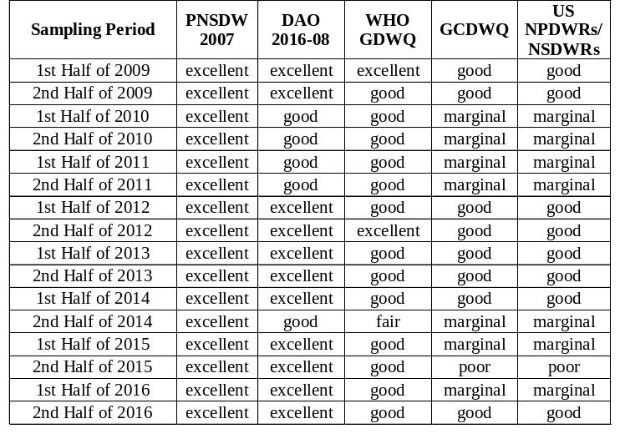
There can be many causal factors for the variations and concentrations of the physical and chemical water quality parameters in the groundwater in Dasmariñas. First of all is hydrogeology, providing the natural concentrations of these parameters. The type and the solubility of the rocks present greatly affect most of the parameters analyzed, but since the geology in the groundwater in the city is unknown, no conclusions have been made involving it. The other factors affecting the physicochemical quality of groundwater are urban and agricultural run-off, waste disposal, and other anthropogenic factors, which effects can be heightened due to urbanization in the city. Being the primary source of water supply for a long time now could also cause the changes. If there has been over pumping of the wells already, several problems could have aroused in addition, like saline water intrusion.
References
Al-Adamat, R., Al-Mashagbah, A., and Salameh, E. (2012), The use of Kriging Techniques with in GIS Environment to Investigate Groundwater Quality in the Amman-Zarqa Basin/Jordan. Research Journal of Environmental and Earth Sciences, 4(2),177-185.
Barcelo, D., Borrell, E., Campos, S., Tauler, R., and Terrrado, M. (2010), Surface-water-quality indices for the analysis of data generated by automated sampling networks. Trends in Analytical Chemistry, 29(1), 40-52
Hasssan, J. (2014), A Geostatistical approach for mapping groundwater quality (Case Study: Tehsil Sheikhupura). International Journal of Science and Research (IJSR), 3(4), 239-245.
Philippine Statistics Authority (PSA) (2015), Census of Population (2015): Total Population by Province, City, Municipality and Barangay (Report). Philippines.

